# TASK# 1

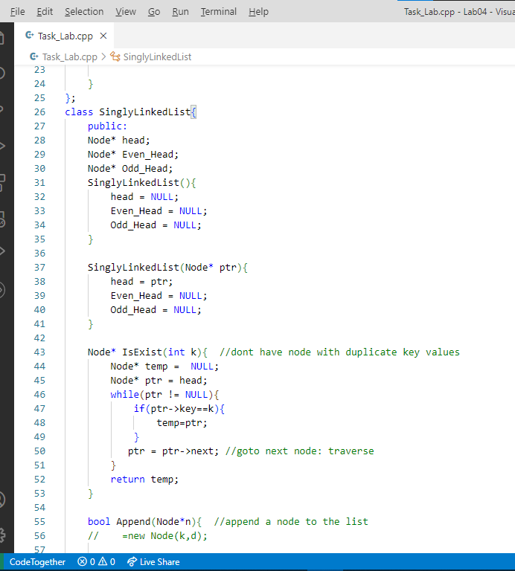

# TASK# 2

# TASK# 3

# TASK# 4

# TASK# 5

# TASK# 6

# TASK# 7

# OUTPUT SCREEN



